
October 2026

Towards a Costing and Pricing Framework for Commonwealth Supported Places in Universities
  - Discussion paper



With the exception of the Commonwealth Coat of Arms, the Australian Government logo, any material protected by a trademark and where otherwise noted all material presented in this document is provided under a Creative Commons Attribution 4.0 International (https://creativecommons.org/licenses/by/4.0/) licence.
The details of the relevant licence conditions are available on the Creative Commons website (accessible using the links provided) as is the full legal code for the CC BY 4.0 International (https://creativecommons.org/licenses/by/4.0/legalcode)

Contents
1. Executive summary 4
2. Introduction 8
3. Pricing context and development 11
4. Framework requirements 14
5. Pricing advice objective 14
6. Costing and Pricing principles 15
7. Costing and Pricing interaction 16
8. Costing and Pricing methodology 19
9. Proposed pathway and timeline 24
Appendix 1: Key terms 26

This discussion paper outlines the proposed structure of the Australian Tertiary Education Commission’s (the ATEC’s) Costing and Pricing Framework for Commonwealth supported places in universities. This Framework will guide how the ATEC develops evidence-based costing and pricing advice to Government. The Framework forms part of the ATEC's iterative approach to developing its costing and pricing methodology and informing future advice on higher education pricing.
This discussion paper is about how the ATEC will develop evidence-based pricing advice. It does not determine final funding amounts, student contribution settings, the Commonwealth-student cost-sharing proportions or implementation timings.
Wording and parts from this document may be incorporated into the ATEC’s final Costing and Pricing Framework, which will guide the ATEC's development of costing and pricing advice to Government. No part of the document has been endorsed by the Australian Government.

Executive summary

Purpose of this discussion paper
The ATEC is developing its Costing and Pricing Framework for Commonwealth supported places (CSPs) in universities (the Framework). This work will inform the provision of evidence-based costing and pricing advice from the ATEC to Government on options to establish a new way of funding CSPs in universities.
This discussion paper outlines the proposed objectives, principles, scope and methodology that would form the Framework, including an approach to estimate, for the first time, an efficient cost of delivering teaching and supporting scholarship at Australian universities. To support this work, the paper also proposes a new data collection, the Australian Universities Costs Dataset (AUCD), to provide the evidence base for efficient-cost estimation.
The Working Group on Higher Education Costing and Pricing (the Working Group) has supported the overall direction and identified principles for this work, which are outlined in the Working Group's interim report.
The ATEC invites stakeholders to provide feedback and evidence on the proposed approach, the associated data collection or methodology and any areas requiring further evidence or testing. Consultation is intended to refine and strengthen the Framework rather than reconsider the broader direction set through the Working Group’s deliberations.
Current funding arrangements outlined in the Higher Education Support Act 2003 (HESA 2003) provide the basis for government funding of CSPs. However, there is currently no established mechanism for systematically testing whether funding amounts and their relativities reflect contemporary costs and delivery practices. Given the tight fiscal environment, it is particularly important that the ATEC understands the efficient cost of delivering specific courses of study at the unit level, as well as costs within institutions and across the higher education sector before it can deliver its pricing advice. The Framework aims to establish a transparent, systematic and reviewable structure for assessing efficient costs and providing independent advice to Government.

Scope and role of the Framework
The Framework describes how the ATEC will develop advice on the efficient cost of delivering teaching and supporting scholarship and how the evidence will inform cost groupings, base funding amounts (referred to in this document as total price) and potential pricing adjustments. It also outlines the proposed data, analytical methods, governance and review arrangements that will support the development of pricing advice.
The Framework does not determine funding levels, student contribution amounts or implementation arrangements, nor does it make any presumption about a need for additional funding. Government remains responsible for policy and funding decisions, while the Department of Education will support the Minister to consider the ATEC’s pricing advice.

Overview of proposed methodology
The proposed Framework centres on estimating the efficient cost of delivering teaching and supporting scholarship and on translating that evidence into the ATEC’s pricing advice to Government. Efficient cost, a term taken from the ATEC’s remit in the Universities Accord (Australian Tertiary Education Commission) Act 2026 (the Act), is defined in this paper as the cost that reflects contemporary teaching and scholarship practices for a typical student cohort based on achieving a sector-wide standard of quality. This is to inform an activity-based pricing approach that sets base prices according to the activities and resources required for delivery and provides a more accurate and transparent price, where different courses of study require substantially different resources in delivering teaching and scholarship.
To support this work, the ATEC proposes to establish a new, sector-wide university data collection – the Australian Universities Costs Dataset (AUCD) – to capture expenditure and revenue information across all university activities.
The AUCD will improve upon previous efforts to examine university costs through its granularity, methodological transparency and whole-of-institution coverage. It will collect unit-of-study level information on teaching activities, provide greater visibility on cost allocation methodologies and capture information across a university’s full range of activities. The AUCD will provide the primary evidence base for analysing teaching and scholarship costs, assessing cost drivers and developing costing and pricing advice. All universities will be invited to participate in the AUCD.
The Framework will also examine whether total price should continue to be predominantly variable (that is, varies directly with the number of Equivalent Full-Time Student Load (EFTSL)) or whether a mixed model, incorporating both fixed and variable funding components based on efficient costs, is supported by the evidence. The fixed component in such a model would reflect those costs which are common across all universities and may not vary directly with size.

Costing and Pricing objective and principles
The objective of the ATEC's costing and pricing advice is to inform Government on evidence-based prices that support the delivery of efficient, high-quality, accessible and sustainable higher education. Pricing advice should reflect contemporary costs, account for material variation in delivery costs and support a diverse higher education sector operating in accordance with the National Tertiary Education Objective (NTEO).
The proposed methodology is guided by six principles:
- Outcome-focused
- Transparent
- Comprehensive
- Evidence-based
- Stable
- Administratively practical.

Stakeholder feedback
The ATEC is seeking stakeholder views and evidence on priority areas that will help inform the development of future costing and pricing advice. This discussion paper seeks input on:
- The proposed objective and principles for costing and pricing advice for CSPs
- Efficient-cost analysis and efficient cost-reflective pricing advice
- Potential pricing adjustment mechanisms for structural cost drivers
- Data collection and methodological approaches
- Governance, transparency and review arrangements.
Feedback is invited from higher education providers, peak bodies, student representative organisations, First Nations stakeholders, government agencies and any other interested parties. Feedback and evidence received will inform the refinement of the Framework to guide the ATEC's structure and methodology of determining its pricing advice.

Key questions
The following questions focus on issues where provider experience, operational knowledge and sector evidence are critical and where insights may not be apparent from current cost data alone. In particular, the ATEC invites feedback and evidence on the following questions:
- Is the proposed Pricing Objective suitable for the ATEC to conduct its pricing work?
- Are the proposed Costing and Pricing Principles appropriate for the ATEC to base its pricing advice on?
- How should funding through prices (base funding amount) for CSPs interact with other mechanisms such as targeted programs or loadings?
- What changes (previous, current or anticipated) have had the biggest impact on the cost of delivering teaching and supporting scholarship in Australia? Please provide supporting evidence.
- Should the ATEC incorporate an additional mechanism that recognises and supports universities with better educational outcomes? If so, how might this be determined and what evidence could be used to support such a mechanism?
- Should the ATEC’s pricing advice, including cost groupings, be predominantly based on the efficient cost of delivery of higher education? Are there any concerns on this proposed approach and if so, please provide supporting evidence to support your stance?
- Should the ATEC recommend a mixed model of funding? Should this be applicable for all universities, or only to 'smaller' universities (to be defined)? If a mixed model of funding were pursued, how should the proportion of fixed and variable funding be determined and what evidence can be used in this consideration?
- The Framework currently highlights an imbalance between depreciation and capital reinvestment as a measure of sustainability. Should the ATEC recognise this sustainability issue? What factors and evidence should the ATEC take into account in this assessment, recognising inherited asset positions?
- The Framework currently proposes a triennial (3-yearly) major update, balancing stability and responding to future changes. Is a triennial update an appropriate period for such an undertaking?

Introduction
The Australian Tertiary Education Commission (ATEC) is the independent steward for Australia’s higher education system. The ATEC has been tasked with creating a better, fairer tertiary education system that delivers for students and progresses the National Tertiary Education Objective (NTEO). The establishment of the ATEC was one of the key recommendations of the Australian Universities Accord.
The Universities Accord (Australian Tertiary Education Commission) Act 2026 (the Act) came into effect on 29 April 2026. Among the ATEC’s functions is the provision of independent advice to Government on the tertiary education system including in relation to:
ii. the efficient cost of higher education across disciplines and student cohorts and in relation to the Commonwealth contribution amounts for places in funding clusters;…” (Subparagraph 11(d)(ii))
The Act uses the term ‘cost of higher education.’ The term ‘delivering teaching and supporting scholarship’ is used here, to make explicit the interactive and joint nature of teaching and scholarship in higher education. ‘Supporting scholarship’ includes direct supports for teaching including innovation in pedagogy, curriculum design and contemporary approaches to engaging, supporting and assessing students. It also involves remaining abreast of the discipline to ensure that courses are up to date and relevant.
The ATEC acknowledges most academic staff are appointed into roles involving both teaching and research. While broader research costs are out of scope (see Table 1), research expenditure may be examined by the ATEC to understand teaching costs, cost allocation practices and the relationships between teaching, scholarship and research.
The overarching aim is that the base funding amounts (referred to as total price) should enable sustainable, high-quality teaching and supporting scholarship for all providers, aligned with each provider’s mission.
The Act distinguishes two domains of advice, the first about costs and the second about Commonwealth contribution amounts. The term ‘total price’ is used in this paper to refer to the total payments to a university for teaching and supporting scholarship. This is the sum of the Commonwealth contribution amount and the student contribution amount.

Scope of the ATEC Costing and Pricing Framework
The ATEC Costing and Pricing Framework (the Framework) will guide the provision of evidence-based advice by the ATEC to support funding decisions for CSPs in universities.
The Framework will outline the objectives, principles and methodology that guide the ATEC's estimation of efficient costs and development of pricing advice to Government. It will establish a transparent and systematic approach to estimating the efficient cost of delivering teaching and supporting scholarship at Australian universities and explain how this evidence will inform advice on cost grouping, price amounts and potential price adjustments.
The Framework will also describe the data, analytical methods, governance and review arrangements that support the development of pricing advice. As part of this work, the ATEC proposes to establish the Australian Universities Costs Dataset (AUCD), which will provide the primary evidence base for efficient-cost estimation and analysis of higher education delivery costs.
The Framework does not determine funding levels, student contribution amounts, implementation arrangements or the overall funding available to the sector. Government remains responsible for final policy decisions, while the Department of Education will continue to support the Minister in considering the ATEC’s advice.
The Framework focuses on identifying total prices for CSPs by examining the efficient cost of delivering teaching and supporting scholarship.
The funding of research and research training is outside the scope of this work. The Framework does not seek to price research as a separate activity. However, the ATEC intends to collect and consider research-related costs (through the AUCD) where necessary to understand the full cost of delivering high-quality teaching and scholarship, or where research activity materially affects observed teaching costs and cost allocation methods. Similarly, while the Framework does not address the funding arrangements for international students or domestic full fee-paying places, information in these activities may be considered where it contributes to a better understanding of the cost of delivery for high-quality teaching and learning for domestic students.
Finally, the Framework seeks to clarify the role of pricing within the broader higher education funding system. It will examine where efficient teaching and scholarship costs are most appropriately recognised through the total price (see Appendix 1), pricing adjustments or other funding mechanisms. The Framework will also provide a transparent basis for understanding how pricing interacts with needs-based funding arrangements, targeted support programs and broader funding policy objectives.
Table 1: Items in scope and out of scope for the ATEC’s costing and pricing advice
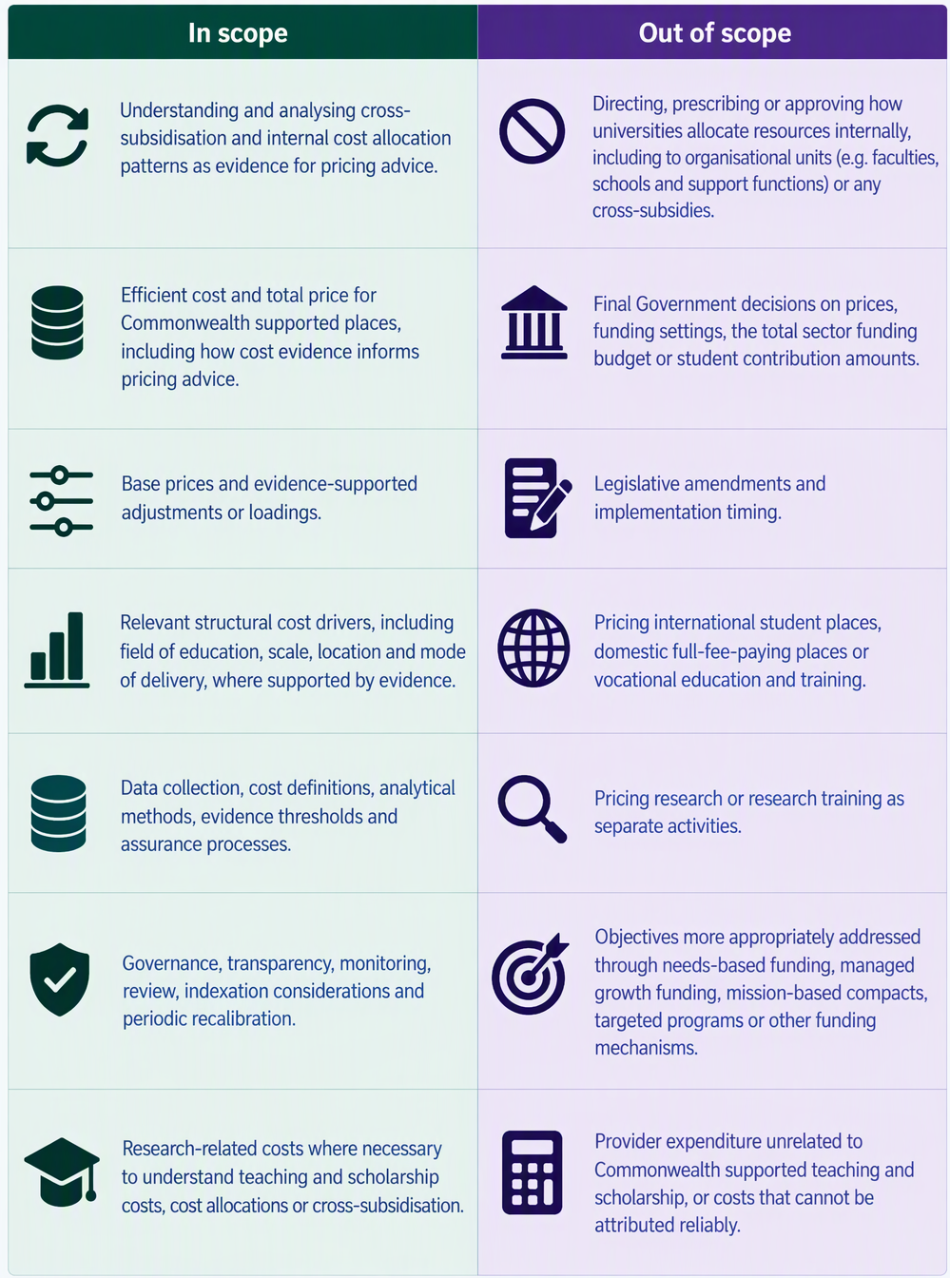

Where the Framework sits within the overall pricing system
The Framework is intended to support transparency, consultation and stakeholder understanding before final advice is developed and provided to Government. Higher education pricing operates within a broader system of stewardship, policy, funding and regulation. The ATEC, Department of Education and Tertiary Education Quality and Standards Agency (TEQSA) each have distinct responsibilities within that system. Understanding these roles helps clarify how pricing advice is developed, considered and implemented. The respective roles of these bodies are outlined below:

Role of the ATEC
ATEC is the independent steward of the higher education system, established under the Act. For costing and pricing, the ATEC will provide independent evidence-based advice to the Government. As system steward of tertiary education, the ATEC is also able to better connect its pricing advice to be aligned with the NTEO and other systems such as mission-based compacts and the Managed Growth Funding System. This allows the ATEC to provide more fulsome and coherent stewardship of the higher education sector.

Role of the Department of Education
The Department of Education remains the Commonwealth’s policy, legislative, funding and program administration body for higher education. It administers major funding mechanisms under the Higher Education Support Act 2003, including the Commonwealth Grant Scheme (CGS), Higher Education Loan Program (HELP) and other grants that support teaching, learning, equity, disability support, and outreach.
For pricing, the Department will support the Minister to consider the ATEC’s pricing advice, undertake its own policy and fiscal analysis, advise on implementation options as needed, and broader reform implications. This includes budget measures, legislation, determinations and payments. It administers the CGS, where Government subsidises tuition costs for Commonwealth supported students, and leads the implementation of higher education reforms guided by the Universities Accord (Opening the Doors of Opportunity) Act 2026, including the Managed Growth Funding System and ongoing Needs Based Funding arrangements.

Pricing context and development

Overview of setting prices
For the purposes of this discussion paper and the Framework, the total price refers to the total resourcing associated with delivering teaching and supporting scholarship for a CSP, comprising of both the Commonwealth and student contributions. The price is expressed on an Equivalent Full-Time Student Load (EFTSL) basis and will be applied through cost groupings that aggregate fields of education (FoE) with similar efficient delivery costs.
The ATEC's pricing advice will seek to align total price with the estimated efficient cost of delivering teaching and supporting scholarship, having regard to applicable quality and regulatory requirements.

Importance of getting the price right
An appropriately calibrated price enables efficient, high-quality teaching and scholarship while promoting value for money for Government and students. Material differences between total price and efficient costs may affect provider behaviour, resource allocation and value for money.
For example, if total funding from Commonwealth and student contributions is below a reasonable cost of teaching, providers may be forced to reduce course offerings, increase class sizes, limit practical learning or cross-subsidise teaching from other activities. Conversely, funding materially above delivery costs can result in inefficient public expenditure and distort provider incentives.
The Framework therefore seeks to develop a transparent and evidence-based approach to estimating efficient costs recognising legitimate differences in costs across structural cost drivers to inform advice. The ATEC’s advice will be based on standardised cost evidence and efficient-cost analysis. This includes a new data collection on more detailed (unit-of-study level) expenditure, activity and costing information to support the development of a consistent evidence base. Detailed reporting requirements and collection requirements will be developed separately.
In formulating its advice on prices, the ATEC will take into account the interactive nature of teaching and scholarship broadly defined.

Sector and market impacts
The ATEC will assess how the proposed pricing approach may influence higher education provision across different FoEs, geographic locations and modes of delivery. It will also consider whether pricing changes may create unintended incentives that affect provider behaviour, student choice or the allocation of resources across the higher education system.
Before providing final advice, the ATEC will assess the distributional impacts, implementation risks and broader system impacts of proposed pricing approaches.

Pricing advice development
Figure 1 provides an overview of the proposed process for developing pricing advice. The process is indicative only and does not pre-empt future Government decisions on pricing arrangements.
The ATEC’s pricing advice will be informed by cost evidence, analysis and consultation.

Figure 1: Overview of the process for the development and delivery of the ATEC’s costing and pricing advice
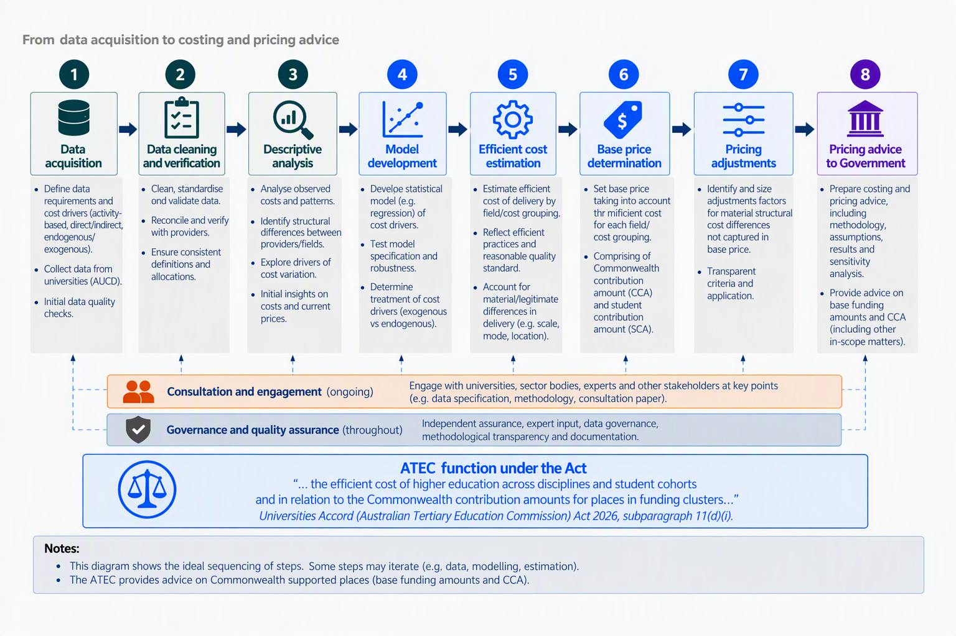

Framework requirements
Australia’s current approach to funding CSPs provides a workable basis for allocating funding. Funding clusters and indexed contribution amounts are embedded across the sector through legislation (HESA 2003).
The Framework seeks to establish a transparent, evidence-based structure for assessing whether the current total prices (comprising of Commonwealth contribution and student contribution amounts) reflect the efficient cost of delivering teaching and supporting scholarship. While existing arrangements have been informed by previous reviews, the relationship between funding relativities, underlying costs and policy judgements is not always clear to the sector. Current funding arrangements are also not designed for periodic reassessment of efficient costs as they require legislative changes. The Framework is intended to provide a more systematic and reviewable basis for assessing efficient costing and inform future pricing advice.
When working within the Framework, the ATEC will test whether material differences in delivery costs exist across FoEs and are influenced by other structural factors, such as scale, location, placements, specialised facilities and delivery methods. The ATEC will assess whether current arrangements create material misalignment between funding and efficient costs of delivering teaching and supporting scholarship to inform the ATEC’s advice to Government.
The Framework signals a shift towards a more evidence-based and transparent approach to pricing advice. Over time, this will involve greater use of detailed university cost and activity data to better understand the efficient cost of delivering teaching and supporting scholarship, the factors that influence those costs, and whether current pricing arrangements remain aligned with contemporary delivery practices.

Pricing advice objective
The objective of the ATEC's higher education pricing advice is to provide Government with evidence and analysis on prices that would support efficient, high-quality education across a diverse range of nationally accessible disciplines and sustainable universities (and other providers), in the context of the National Tertiary Education Objective and mission-based compacts negotiated with universities..
This objective recognises the diversity of costs, delivery models and institutional missions across the sector. This objective has been endorsed by the Working Group on Higher Education Costing and Pricing. Stakeholder feedback will inform the continued development of the Framework and the ATEC's future pricing advice to Government.
Consistent with this objective is that:
- Pricing advice will be evidence-based and reflect the efficient cost of provision. Pricing advice will consider the contemporary cost of provision and also take into account that some units in some universities cost more to deliver.
- Quality is important. Quality teaching and learning should be informed by scholarship and enable universities to provide quality teaching and scholarship in line with national standards.
- Pricing advice accounts for systematic and material variation in the cost of delivery, including potentially those driven by economies of scale, delivery methods and FoE.
- University education should be nationally accessible. Pricing advice should help to ensure that key FoEs are available across Australia, and that a broad range of fields are viable nationally.
- Universities are financially sustainable. Pricing advice should reflect the contemporary costs of provision across universities and identify implications for the sustainability of different provider types (provided they are operating efficiently).
Consultation Question
- Is the proposed Pricing Objective suitable for the ATEC to conduct its pricing work?

Costing and Pricing principles
The pricing objective describes the outcomes that higher education pricing advice should seek to achieve. The principles below guide the development of that advice and provide a basis for considering trade-offs for the ATEC in developing its advice. These principles have been endorsed by the Working Group on Higher Education Costing and Pricing.
The ATEC’s pricing approach is guided by six principles:
- Outcome-focused: Any costing and pricing advice should be in the context of clear Government objectives for higher education – recognising the unique role of universities and the funding mechanisms in supporting these aims. Achievement of a world-class higher education system requires a diverse range of institutions, with their own unique missions, specialisations and offerings.
- Transparent: The new approach should be clear in intent and transparent in method.
- Comprehensive: The new approach should aim to estimate the total costs of university functions. The dataset (AUCD) should include costs such as teaching and learning, intermediate services that support teaching and scholarship including general operating costs, support services, buildings, facilities and engagement with community or industry and meeting quality standards and compliance costs. Understanding university costs needs to explicitly consider all elements required to achieve the intended outcomes of a world-class higher education system.
- Evidence-based: Recognising the heterogeneity of the higher education sector, the new approach should reflect (reasonable) existing internal resource allocation relativities as applied by universities including costs of space and equipment. The total price (i.e. excluding one-off grants for a particular purpose/project) should be based on empirical evidence.
- Stable: The price relativities should aim to be consistent and predictable over time. Prices may be updated at agreed intervals to take account of new information or approaches to teaching, including new technologies.
- Administrative ease: Funding arrangements and required data collection should not unduly increase the administrative burden on universities. Some complexity and administrative burden are unavoidable, but this should be minimised.
Application of these principles may require trade-offs. The Framework seeks to achieve an appropriate balance between these competing considerations.
Consultation Question
- Are the proposed Costing and Pricing Principles appropriate for the ATEC to base its pricing advice on?

Costing and Pricing interaction

Definitions
The following terms are defined for the purposes of the ATEC's Costing and Pricing Framework and its development of costing and pricing advice to Government.

Total Price
The total price is the total funding associated with a CSP, comprising the Commonwealth contribution and the student contribution, expressed on an EFTSL basis. This is commonly referred to as base funding amount.
Note, the current Commonwealth contribution and student contribution amounts are set under the HESA 2003 (Part 2-2 and Part 3-2).

Cost
The cost refers to the observed or estimated expenditure incurred in delivering teaching and supporting scholarship for one EFTSL. Costs will differ among universities. Pricing will be based on the efficient cost, as defined below.

Efficient cost
The ATEC will develop pricing advice that reflects differences in the cost of delivering teaching and supporting scholarship across FoEs, other relevant cost drivers and other factors including supporting scholarship.
The term ‘efficient cost’ is not defined in the Act. The approach to efficient cost analysis will consider the observed costs across providers, while recognising that not all observed practices, expenditure patterns or delivery models represent efficient provision.
The Framework adopts the following definition:
The ‘efficient cost’ is the cost that reflects contemporary teaching and scholarship practices for a typical student cohort based on achieving a sector-wide standard of quality without avoidable inefficiency.
The efficient cost will reflect evidence across providers and material cost drivers (not necessarily the lowest observed cost). In developing pricing advice, the ATEC will examine whether factors such as, but not limited to, FoE, location, level of study, economies (and diseconomies) of scale and scope and mode of delivery have a material and measurable effect on efficient cost.
‘Avoidable inefficiency’ in the definition recognises that some variation in costs is inherent, driven by exogenous factors, but some variation is potentially avoidable, driven by university choices.
The efficient-cost approach provides a structured basis for assessing whether higher education funding remains aligned with the contemporary costs of delivery for the majority of students without avoidable inefficiency. By improving the alignment between prices and efficient costs, the Framework will support high-quality teaching and scholarship, provider sustainability and broader tertiary education objectives. The Framework also provides a transparent and reviewable basis for advising Government on pricing arrangements as costs, delivery models and system priorities evolve over time.

What does the price cover?
The total price will take into account the efficient cost of delivering teaching and supporting scholarship for a CSP. Costs included in pricing should be necessary for delivery, attributable to teaching and scholarship, efficiently incurred and supported by sufficiently reliable evidence at the unit-level of study where possible.
Costs considered for inclusion will comprise:
- academic and non-academic staff costs attributable to teaching and scholarship
- teaching-related materials, utilities and equipment
- costs associated with laboratories, practical activities, fieldwork, placements and other required forms of teaching delivery
- an appropriate share of facilities and capital-related costs, including depreciation, repairs and maintenance, where these costs are attributable to teaching and scholarship
- student administration, learning support and other services required to deliver Commonwealth supported teaching
- an appropriate share of administration, professional services, information technology and other indirect or shared costs attributable to teaching and scholarship
- scholarship activities necessary to maintain the disciplinary knowledge and capability required for high-quality teaching.
Observed expenditure will not automatically be reflected in price. Shared costs may be considered where attributed through reasonable and consistent allocation methods.
The base price should not include costs that:
- are unrelated to the delivery of teaching and scholarship for Commonwealth supported provision
- relate solely to research or research training, whilst recognising that most academic staff in universities are appointed to ‘teaching and research’ roles
- relate to international students, domestic full-fee-paying provision, vocational education and training, commercial activities or other activities that are not attributable to Commonwealth supported teaching and scholarship
- arise due to inefficient delivery, discretionary provider choices (i.e. are not common across universities) or activities beyond the agreed scope of provision.
Advice on the interaction between pricing and other funding mechanisms, including needs-based funding, will be designed to avoid double payment. While broader research costs are not included in pricing, research expenditure may be examined to understand teaching costs, cost allocation practices and the relationship between teaching, scholarship and research.
The costing process is empirical and looks at the contemporary costs of the teaching and supporting scholarship. Pricing advice uses the efficient cost of provision as a starting point and takes into account a broader range of factors (not least in the context of the ATEC’s stewarding function), including ensuring a sustainable network of universities and disciplines.
Moving from costing to pricing requires consideration of the efficient cost levels within the proposed pricing model to account for avoidable or unusually high expenditure and system sustainability.
As part of its pricing advice, the ATEC may also give consideration to recognising excellence in educational outcomes.

Student contribution amounts
This Framework assumes the existing regulated student contribution amounts are given. That is, in line with the ATEC’s remit under the Act, the Commonwealth contribution amount will be the focus of the ATEC’s advice.
Currently, student contribution amounts vary as a proportion of total payments. Determining the efficient cost of a unit of study must be undertaken before consideration of student contributions so that the student contributions relative to the funding rate in a FoE is understood. This is to ensure, at the extreme, that students are not required to pay more than the efficient cost of provision.
Consultation Questions
- How should funding through prices (base funding amount) for CSPs interact with other mechanisms such as targeted programs or loadings?
- What changes (previous, current or anticipated) have had the biggest impact on the cost of delivering teaching and supporting scholarship in Australia? Please provide supporting evidence.
- Should the ATEC incorporate an additional mechanism that recognises and supports universities with better educational outcomes? If so, how might this be determined and what evidence could be used to support such a mechanism?

Costing and Pricing methodology

Efficient-cost reflective pricing approach
The Framework aims for the total price to use the efficient cost of delivery as a central starting point to ensure that funding reflects the resources reasonably required to provide high-quality education without compensating for avoidable inefficiency. The ATEC may consider further adjustments in addition to the base price in situations where a material cost driver is not adequately reflected through the base price (see ‘adjustment factor determination’ section).
This is being proposed through an activity-based approach. This approach identifies key activities (i.e., teaching, scholarship and other university activities) and their cost drivers (e.g., teaching hours, laboratory use, specialist staff, student support, etc.) and draws on the allocations used in internal university approaches to allocate costs according to the resources used for the delivery of each activity.
Activity-based costing calculates the cost of delivering an activity by assigning expenses to the specific activities and the resources it consumes. Activity-based pricing sets base prices according to the activities and resources required for delivery. For example, a higher price may be assigned to a course that has more laboratory usage because it consumes a more costly resource than a course that does not require laboratory usage, keeping everything else the same.
An advantage of this approach is that it provides a more accurate and transparent price, particularly where different courses or services require substantially different resources in delivering teaching and supporting scholarship and identifying the main cost drivers empirically. However, this approach is highly dependent on reliable, granular activity and cost data.
The ATEC will also aim to distinguish between structural factors that affect costs across providers (exogenous factors) and costs arising from provider-specific choices (endogenous factors). Universities differ in their course design, student-to-staff ratios, class sizes and delivery approaches. While this diversity can support innovation and responsiveness, provider-specific choices will generally not be reflected in the pricing approach, unless they represent a material difference and efficient cost of provision.

Mixed-model approach for funding
The current funding arrangement for CSPs is ‘variable’, meaning that it is directly linked to eligible student load. The ATEC will examine whether pricing should continue to be predominantly variable or adopt a ‘mixed model’, in which the suggested per EFTSL pricing (i.e. funding) comprises both fixed and variable components.
A model which includes a fixed component may be appropriate where efficient provision involves common or unavoidable costs that do not vary proportionately with student load such as costs of regulatory compliance and basic corporate overheads. A fixed component would only be included where these costs are material, measurable, efficiently incurred and not recognised elsewhere. A ‘stepped’ approach might also be considered where the ‘fixed’ component may reflect differences across different institutional size ranges.
The variable component would vary directly with the number of EFTSL and would change according to measurable cost drivers such as student numbers and enrolment load, allowing funding to respond to actual volume and associated costs.
This approach may advantage smaller universities by recognising that they must provide certain activities common across all universities but have fewer students - over which these costs can be shared.
Should the evidence support a mixed model of funding, the ATEC would need to consider its scope, including whether it should apply universally or only where there is evidence of material fixed costs that are not adequately recognised.

Australian Universities Costs Dataset
All universities will be invited to participate in the Australian Universities Costs Dataset (AUCD). In line with the principle of administrative ease, it is expected that only universities with robust internal costing systems will participate. University participation will be voluntary, and a university’s individual data will not be identified in any public reporting, nor outside the ATEC’s costing and pricing team and the Commissioner overseeing this work.
The AUCD has three key features that improve on previous efforts to gather evidence on the cost of higher education delivery. These are:
- Granularity: Teaching activity data will be captured at the unit-of-study level. For each unit-of-study, information will be collected on contextual and activity details, revenue and expenditure. This level of detail will allow the ATEC to examine differences in delivery costs that may be obscured in data aggregated across broad FoEs or whole institutions. It will provide a stronger basis for developing pricing advice from observed differences in the costs of higher education delivery.
- Methodological transparency: Universities differ in their financial systems, organisational structures, costing models and the information available to support cost allocation. To assist the ATEC distinguish material differences in delivery costs from differences caused by accounting classification and allocation methodologies, universities will be expected to provide a summary of their allocation methodology, and key datasets and cost drivers used.
- Whole-of-institution coverage, reconciliation and cross-subsidisation: In addition to detailed information on teaching, universities will be asked to provide information on other activities, albeit at a more aggregated level. This whole-of-institution approach provides an internal consistency check, helping to identify omissions and duplication. It also promotes balanced allocation across activities, as expenditure attributed to teaching cannot simultaneously be attributed to another university activity.
The choice between a predominantly variable model and a mixed model will be informed by the AUCD. The AUCD will comprise of standardised revenue, expenditure and activity information from participating universities and provide the primary evidence base for analysing teaching and scholarship costs, assessing cost drivers and developing pricing advice.
The data will reflect contemporary university delivery approaches to delivering teaching and supporting scholarship and will incorporate an understanding of university costing methodologies to support consistent comparison and interpretation of results across providers. The AUCD methodology will need to be adaptable as delivery practices, technologies and institutional arrangements change. Data requirements will seek to balance analytical detail with reporting burden.
The robustness of the AUCD will depend on participation from a sufficiently representative range of universities. If overall participation is limited, the ATEC may require alternative analytical approaches or additional data sources as participants will initially be limited by current institutional data capabilities. The ATEC will work to expand the AUCD over time. Detailed collection, governance, privacy, confidentiality and assurance arrangements will be developed separately.
The ATEC will initially aim for about 15-20 universities to participate, reflecting a representative range of universities, and accounting for a significant proportion of enrolments. To enable a greater number of universities to participate, the ATEC will ensure there is a reasonable amount of time provided for universities to respond to the AUCD request. It is expected that the number of participating universities and the data specification will evolve over time.

Sustainable costs
Observed expenditure may not represent a sustainable level of provision, including but not limited to where universities have deferred necessary investment in capital development. The ATEC will consider whether and how efficient-cost estimates should account for this, including the extent to which efficient costs should reflect long-term sustainability.

Cross-subsidised activity
The AUCD will enable the ATEC to understand cross-subsidisation between FoEs, student cohorts and other institutional activities. This analysis will help distinguish the cost of provision from the way universities currently allocate resources across universities.

Cost groupings and Field of Education (FoE)
Cost groupings will provide the primary structure for translating efficient-cost evidence into a manageable set of prices. Each cost grouping will group FoEs with sufficiently similar efficient delivery costs per EFTSL to support development of a common price.
FoE, classified using the Australian Standard Classification of Education (ASCED), is expected to be the starting point for the cost grouping design. The ATEC will use the AUCD to collect information at the 6-digit level to test the alternative groupings, including whether material and persistent cost differences support separate groupings.
Cost grouping design will balance alignment with efficient costs with stability and administrative simplicity. Potential groupings will be assessed against:
- the materiality and persistence of differences in efficient cost
- the similarity of costs within, and differences among, proposed groupings
- the coverage and quality of supporting data
- stability and administrative practicality
- the risk of unintended incentives or classification changes
Where a cost difference is not suitable for inclusion in a total price, the ATEC will consider whether it is better addressed through an adjustment or another policy mechanism. Each cost should have one primary treatment to avoid double counting.
The final number and composition of cost groupings will be informed by analysis, consultation and sensitivity testing, with the preferred approach identifying the smallest manageable number of cost groupings that materially improves the alignment between prices and efficient costs.

Recognition of material cost differences
The ATEC will seek to recognise material differences in efficient cost through the standard pricing architecture, including cost groupings, base price and any adjustments. A higher observed cost alone would not justify a different pricing treatment, as differences may reflect provider choices, accounting or allocation practices, temporary circumstances or inefficient delivery.
In determining whether a cost difference warrants specific treatment, the ATEC will assess whether it:
- reflects a material and persistent difference in efficient cost
- is supported by reliable and comparable evidence
- relates primarily to factors outside provider control
- can be measured and administered consistently
- is not already recognised through cost groupings, total prices, adjustments or other funding arrangements
- would improve alignment between prices and efficient costs
- avoids creating unintended disincentives or classification distortions
- is more appropriately addressed through pricing than through another policy or funding mechanism.
Where these criteria are met, the ATEC may recommend changes to cost grouping design, an adjustment, or another funding mechanism. The ATEC may also conclude that no specific pricing response is warranted. The pricing advice will explain the supporting evidence and rationale, interactions with other funding arrangements and any proposed review arrangements.

Analytical approach
The ATEC will examine expenditure and activity information across participating providers to estimate efficient costs, test cost grouping structures and assess potential adjustments. The analysis will distinguish material structural cost drivers from provider-specific choices, accounting practices and allocation methods.
This work will yield a set of cost relativities for different FoE cost groupings and adjustments.
Quantitative results will inform, but not automatically determine, pricing advice. The ATEC will also consider data quality, methodological limitations, consultation feedback, implementation considerations and the broader pricing objectives.

Base price determination
The ATEC will consider the price for each cost grouping and the benefits of applying a grouping relativity to an overall base price. The base price could be indexed annually (consistent with current provisions in HESA 2003). Cost groups and relativities could be reviewed triennially (3-yearly) to take into account the changing nature of approaches to teaching.
The resulting prices and grouping relativities are not intended to be designed to reimburse each provider's actual expenditure but rather reflect an overall sector sustainable efficient cost.

Adjustment factor determination
The base price will use the efficient cost as a central starting point. However, this may not consider some cost drivers to the full extent on impacting an institution’s expenditure. Where a material cost driver may not be adequately reflected through cost grouping design, or base price, the ATEC’s advice may consider an adjustment in addition to the base price. Potential cost drivers for consideration include, but are not limited to, scale, location and mode of delivery.
Any adjustment will be assessed using the criteria for recognising material cost differences outlined above, including the reliability or persistence of the supporting evidence and whether the factor is largely outside of provider control.
The ATEC will specifically examine whether economies of scale are empirically supported and, if so, whether they should be assessed at the campus or institution level.

Indexation and recalibration
Cost data will necessarily precede the period for which pricing advice applies. Once prices are established, indexation may be used between major reviews to account for changes in input costs and maintain their current value. Currently, indexation is set through HESA 2003 (Part 5-6), where the index is applied for the Commonwealth contribution and student contribution amounts through the Consumer Price Index published by the Australian Bureau of Statistics (ABS) for the relevant quarter.
The ATEC may consider alternative indexation approaches in developing its advice, but the final indexation methodology remains a matter for Government as changing the method of indexation would require amendments to HESA 2003.
Recalibration is distinct from indexation. Recalibration involves reassessing the efficient-cost model, cost grouping relativities and structural cost drivers using updated evidence. Recalibration may identify changes in delivery practices, technology or cost relationships that are not captured through common indexation.
The model is proposed to be recalibrated on a triennial basis, subject to monitoring and implementation experience.
Consultation Questions
- Should the ATEC’s pricing advice, including cost groupings, be predominantly based on the efficient cost of delivery of higher education? Are there any concerns on this proposed approach and if so, please provide supporting evidence to support your stance?
- Should the ATEC recommend a mixed model of funding? Should this be applicable for all universities, or only to 'smaller' universities (to be defined)? If a mixed model of funding were pursued, how should the proportion of fixed and variable funding be determined and what evidence can be used in this consideration?
- The Framework currently highlights an imbalance between depreciation and capital reinvestment as a measure of sustainability. Should the ATEC recognise this sustainability issue? What factors and evidence should the ATEC take into account in this assessment, recognising inherited asset positions?
- The Framework currently proposes a triennial (3-yearly) major update, balancing stability and responding to future changes. Is a triennial update an appropriate period for such an undertaking?

Proposed pathway and timeline

Pathway to final pricing advice and potential implementation
The indicative work program for developing pricing advice is outlined in Figure 2. It includes Framework development, data collection, consultation, methodology testing, finalisation and advice to Government. The timing and sequencing of activities may change in response to data quality, provider participation, consultation findings, or other emerging requirements.

Figure 2: Indicative ATEC timeline for development of costing and pricing advice (subject to this consultation)
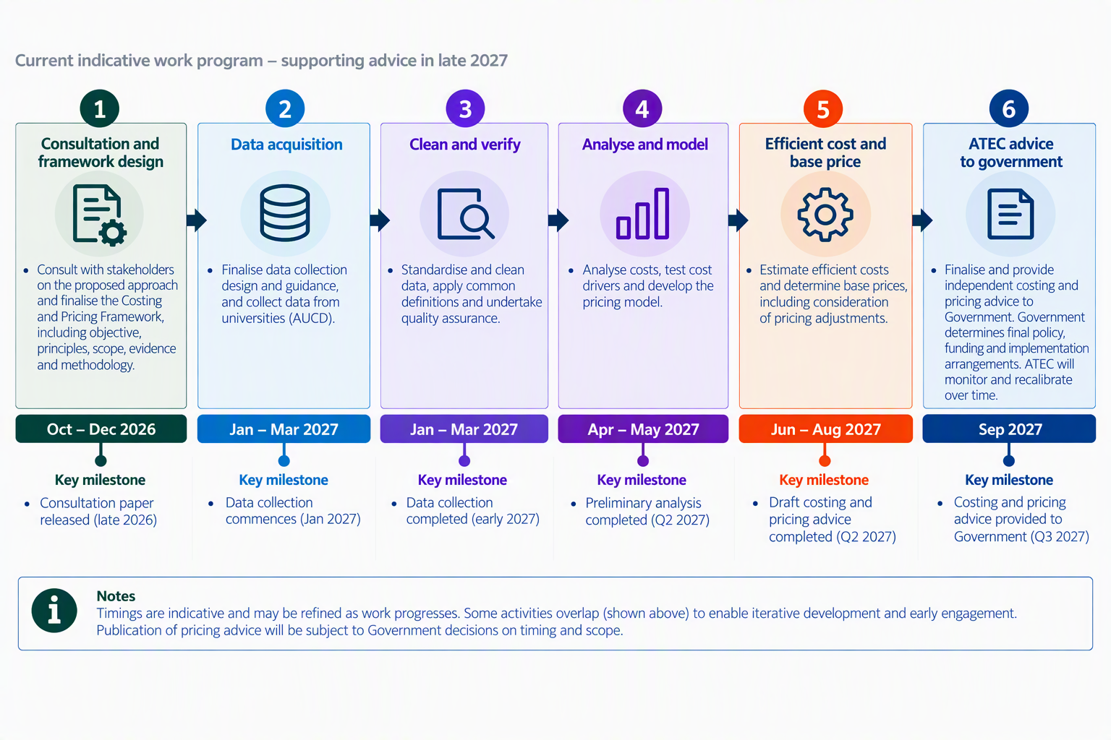

Appendix 1: Key terms
Adjustment or adjustment factor: An additional pricing component that may be recommended where evidence shows a material, measurable and largely structural cost driver not adequately captured in the base price.
Australian Universities Costs Dataset (AUCD): The proposed dataset of standardised expenditure and activity-based costing information collected from participating universities. The dataset is intended to provide the primary evidence base for estimating efficient costs, assessing cost drivers and developing pricing advice.
Commonwealth Supported Place (CSP): A higher education place for which the Australian Government provides a subsidy through the Commonwealth Grant Scheme. Students enrolled in a CSP contribute towards the cost of their education through a student contribution amount, with the remaining amount funded by the Commonwealth.
Commonwealth Contribution Amount (CCA): The portion of the total price for a Commonwealth supported place that is funded by the Australian Government. The Commonwealth contribution amount is determined separately from the student contribution amount and together they comprise the total price.
Cost: Expenditure incurred by universities for delivering a unit of study per Equivalent Full-Time Student Load (EFTSL).
Cost groupings: Units that are grouped together that have similar efficient delivery costs for the purposes of determining pricing amounts.
Efficient cost: The cost that reflects contemporary teaching and scholarship practices for a typical student cohort based on achieving a sector-wide standard of quality without avoidable inefficiency.
Equivalent Full-Time Student Load (EFTSL): A measure of a full-time student’s annual study load (HESA 2003, section 169-27).
Field of Education (FoE): A classification of units of study based on their disciplinary content, generally using the Australian Standard Classification of Education (ASCED). FoE is expected to be a primary factor in the design of cost groupings and the assessment of efficient costs.
Indexation: The process of updating prices between major pricing reviews to reflect changes in costs over time. Indexation maintains the current value of prices but does not reassess underlying efficient costs or pricing relativities.
Observed cost: The cost reported or allocated by providers under existing practices. Observed cost is evidence for analysis but is not automatically treated as efficient cost.
Price (Total Price): The total funding associated with a Commonwealth supported place, comprising the Commonwealth contribution and the student contribution, expressed on an Equivalent Full-Time Student Load (EFTSL) basis. This is analogous to what is often referred to as the base funding amount.
For each Field of Education (FoE), the price will be calculated by multiplying a base price by the price relativity for the FoE.
Recalibration: The periodic reassessment of efficient costs, pricing relativities, cost groupings and other components of the pricing model using updated evidence. Recalibration is distinct from indexation because it examines whether underlying cost relationships have changed.
Structural cost driver: A factor that materially influences the efficient cost of delivering teaching and supporting scholarship and is largely outside provider control. Examples may include Field of Education (FoE), scale, location or mode of delivery. Structural cost drivers may be recognised through cost grouping design, adjustment factors or other policy mechanisms where supported by evidence.
Student Contribution Amount (SCA): The portion of the total price for a Commonwealth Supported Place that is paid by the student. Student contribution amounts are determined by Government and are outside the ATEC's remit.
Teaching and scholarship: The activities required to deliver contemporary, high-quality higher education teaching and learning, including the scholarship necessary to maintain disciplinary knowledge and teaching capability. Supporting scholarship includes direct supports for teaching including innovation in pedagogy, curriculum design and contemporary approaches to engaging, supporting and assessing students. It also involves remaining abreast of the discipline to ensure that courses are up to date and relevant. The ATEC acknowledges that most academic staff are appointed into roles involving both teaching and research.

Working Group on Higher Education Costing and Pricing summary of progress to date report
https://www.abs.gov.au/statistics/classifications/australian-standard-classification-education-asced/latest-release

