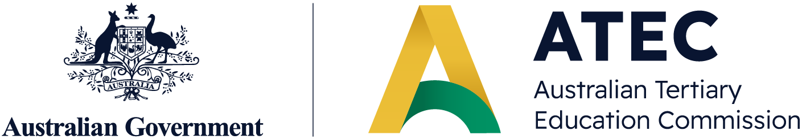
October 2026


ATEC Statement of Strategic Priorities 2027-28 Consultation Paper

Contents
Introduction 3
Overview and role of ATEC 3
Purpose of the Statement of Strategic Priorities 3
Identifying priorities 5
Consultation process 5
Review cycle 6
Outcomes 7
First Nations self-determination and success 7
Equitable access, participation and success 7
Graduate capability and national benefit 8
Research and knowledge for public benefit 8
System quality, diversity and resilience 8
Strategic Priorities 9
National, state/territory and regional priorities 10
First Nations 10
Equity 11
Quality teaching 11
A joined-up tertiary system 12
Research 12
Global engagement 13
Collaboration 13
Student experience and safety 14
Consultation Questions 15

Introduction

Overview and role of ATEC
Lifting educational attainment and expanding lifelong learning opportunities are central to meeting Australia’s long-term skills needs and enabling the personal and societal benefits of tertiary education. This aligns with the Government’s target of 80% of the working-age population with a Certificate III or above by 2050, and the vision of the Australian Universities Accord for a tertiary education system that supports learners to upskill and reskill across their lives.
The Australian Universities Accord Final Report set out a long-term reform agenda to grow participation, improve equity and quality, and strengthen alignment between education and Australia’s skills and knowledge needs. Many of the recommendations of the Accord have now been implemented, including establishment of the Australian Tertiary Education Commission (ATEC) as steward of the higher education system. ATEC commenced operation in an interim capacity in July 2025, and legislation to establish it in an ongoing capacity commenced on 29 April 2026.
ATEC’s role as steward of the higher education system means guiding its quality, equity, strategic direction, and long-term sustainability. ATEC draws on evidence and consults widely to provide coordinated whole-of-system leadership for the tertiary education system.
In the performance of all functions, ATEC is guided by the National Tertiary Education Objective (NTEO) and the objective of improving outcomes for groups facing systemic barriers to education, including Aboriginal and Torres Strait Islander peoples, persons with disability, persons of a low socioeconomic background and persons living in regional Australia.
The National Tertiary Education Objective is the objective for tertiary education in Australia to:
- promote a strong, equitable and resilient democracy; and
- drive national, economic and social development and environmental sustainability.
Purpose of the Statement of Strategic Priorities
Under the Universities Accord (Australian Tertiary Education Commission) Act 2026, the Statement of Strategic Priorities (SSP) is a key stewardship document prepared by ATEC.
Published every 2 years, the SSP sets out ATEC’s priorities for the tertiary education system. It is intended to provide guidance to governments, stakeholders and the public about current challenges and opportunities in tertiary education, and it is required to be considered by ATEC when developing mission based compacts with Table A and B providers.
To support transition arrangements, ATEC released an interim SSP in May 2026, which set out 6 key areas of focus aligned to 2027 mission based compact performance domains. ATEC is now developing its first SSP based on legislation which will provide overarching strategic direction for the work of ATEC and the sector related to the 2027 and 2028 calendar years.
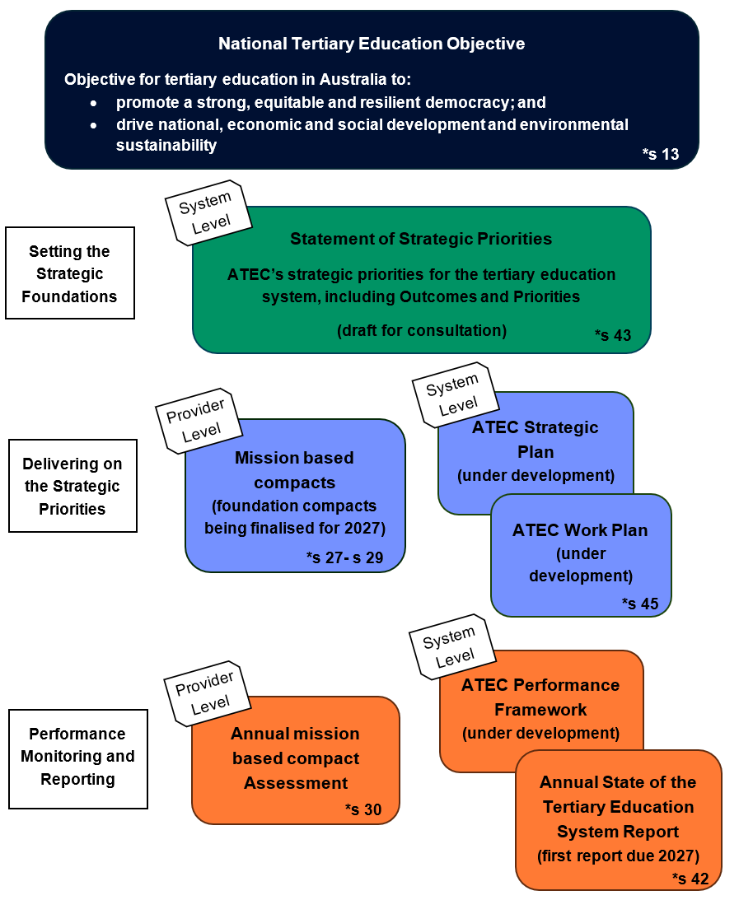
The following figure outlines how the SSP fits into ATEC’s stewardship model.
* Section numbers refer to the Universities Accord (Australian Tertiary Education Commission) Act 2026
The performance framework will include indicators and metrics for both system level outcomes and provider level performance indicators against the strategic priorities outlined below. ATEC will use the performance framework to provide analysis and reporting in the State of the Tertiary Education System report drawing on both system level and provider level indicators and metrics.

Identifying priorities
The tertiary education system is complex, and change takes time. It is important that the SSP balances ambition with stability and practicality. It is also important that the SSP is flexible, allowing providers to focus their efforts on priorities most relevant to their mission, operating context and own strategic vision, ensuring these are aligned to ATEC’s remit.
To that effect, ATEC will consider the following in identifying and finalising priorities for the SSP:
- The National Tertiary Education Objective
- Alignment with ATEC’s legislated objects, functions, and powers under the Universities Accord (Australian Tertiary Education Commission) Act 2026
- The Minister for Education’s strategic priorities
- State and Territory Government priorities
- Insights from the 2027 mission based compact negotiations, interim SSP and engagement with the tertiary education sector
- Relevant sector reviews, including the Australian Universities Accord and the Strategic Examination of Research and Development
- Feedback collected via this public consultation process.

Consultation process
As the system steward, ATEC is committed to a genuine consultation process to inform the development of the SSP. Consultation on the 2027-28 SSP includes hearing from ministers across the Commonwealth and states and territories, peak bodies and advocacy groups, higher education system stakeholders and student representatives, and the public. This will be undertaken through targeted stakeholder consultation and an open public submission process.
The purpose of consultation will be to ensure the SSP is informed by sectoral, student, and community knowledge. The draft outcomes and priorities set out in this paper build upon the interim SSP and are subject to change based on feedback, insights and perspectives from governments and key stakeholders, including the sector.
This consultation process seeks views on the proposed outcomes and priorities for inclusion in the SSP. Consultation does not seek input outside of that scope – for example, on VET delivery or funding settings, or issues outside of ATEC’s remit (such as individual complaints received by the National Student Ombudsman).
Discussion questions are provided at the end of the paper to help in preparing your response. Information about the ways you can have your say are on the ATEC’s website, including providing a submission via email.

Review cycle
ATEC’s strategic priorities are identified with a 2-year time horizon in mind, reflecting where short- to medium-term effort is required. Priorities may remain stable across successive SSPs where they remain relevant, but may also change within or across SSPs to reflect circumstances at the time, for example where sufficient progress has been achieved, or a more critical priority emerges.
Developing and delivering on the SSP is an iterative process. Each SSP will build on the previous one based on evidence, stakeholder feedback, and to align with complementary reforms and priorities. The SSP can be varied within a 2-year period in accordance with section 44 of the Universities Accord (Australian Tertiary Education Commission) Act 2026.

Outcomes
The draft outcomes below draw on the ATEC’s legislated objectives, including the objects in section 3, the National Tertiary Education Objective at section 13, and objective of improving outcomes for persons facing systemic barriers to education at section 14.
The draft outcomes represent the medium- to longer-term future state that ATEC is seeking to achieve for the tertiary education system as a whole. Overall, the desired outcome is a tertiary education system that empowers First Nations peoples, expands equitable access and success, develops a skilled and adaptable workforce, generates and applies knowledge for public benefit, and remains sustainable and responsive to future challenges. Collectively, these outcomes describe a high-performing tertiary education system that delivers social, cultural, economic and community benefit for all Australians.
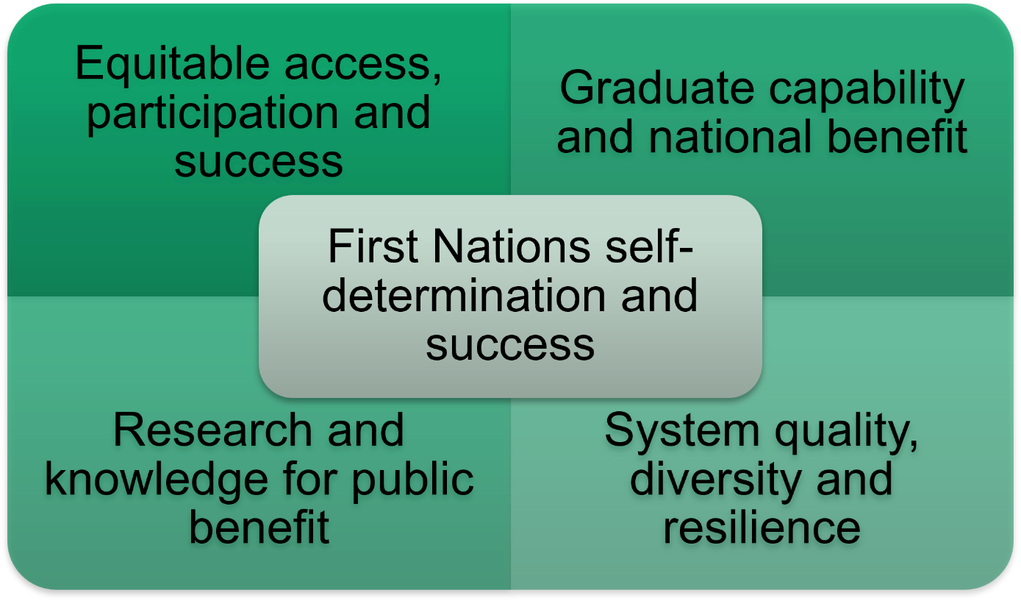
Through its stewardship functions, the ATEC will contribute to the following system-level outcomes:

First Nations self-determination and success
First Nations leadership, voices and knowledge are at the heart of Australia's tertiary education system, enabling self-determination, improving participation and success outcomes, and ensuring higher education better reflects and serves First Nations peoples and communities.

Equitable access, participation and success
All Australians have equitable and affordable access to high-quality tertiary education that enables them to develop the knowledge and skills needed to thrive, regardless of their background or circumstances. Students are safe and well supported throughout their learning to achieve strong educational outcomes. Students are able to progress satisfactorily through their studies finishing in minimum time incurring minimum debt.

Graduate capability and national benefit
Graduates possess the creativity and technical expertise needed to meet evolving workforce, industry and societal needs. Governments, tertiary providers, employers, industry and unions work collaboratively to align education and training with current and emerging skills demand, supporting a productive, resilient and future-ready workforce. The humanities, social sciences and the arts will thrive as a vital part of a dynamic tertiary education system contributing to a well-functioning society and a resilient democracy.

Research and knowledge for public benefit
The tertiary education sector generates, advances and applies new knowledge to address national challenges, drive innovation and improve social, economic, environmental and cultural outcomes. Through excellence in research and research training, it develops the capability, talent and partnerships needed to translate knowledge into benefits for society.

System quality, diversity and resilience
The tertiary education sector is sustainable, diverse and resilient, with the capacity, capability and infrastructure required to meet current and future learner, workforce and community needs. It operates as a dynamic and efficient system that supports quality and innovation.

Strategic Priorities
The draft strategic priorities outlined below have been developed drawing on ATEC's interim SSP, and insights gathered through the foundation mission based compact negotiations and broader engagement with the tertiary education sector.
The strategic priority areas are not intended to align on a one-to-one basis with the outcomes; rather, they identify the areas where focussed effort and attention is required in the short- to medium-term to drive progress towards long term outcomes. Collectively, and in interconnected ways, actions across the proposed priority areas will contribute to achievement of the broader system level outcomes. It is acknowledged that progress towards any individual outcome will often depend on action across multiple strategic priorities.
Existing priorities in the interim SSP
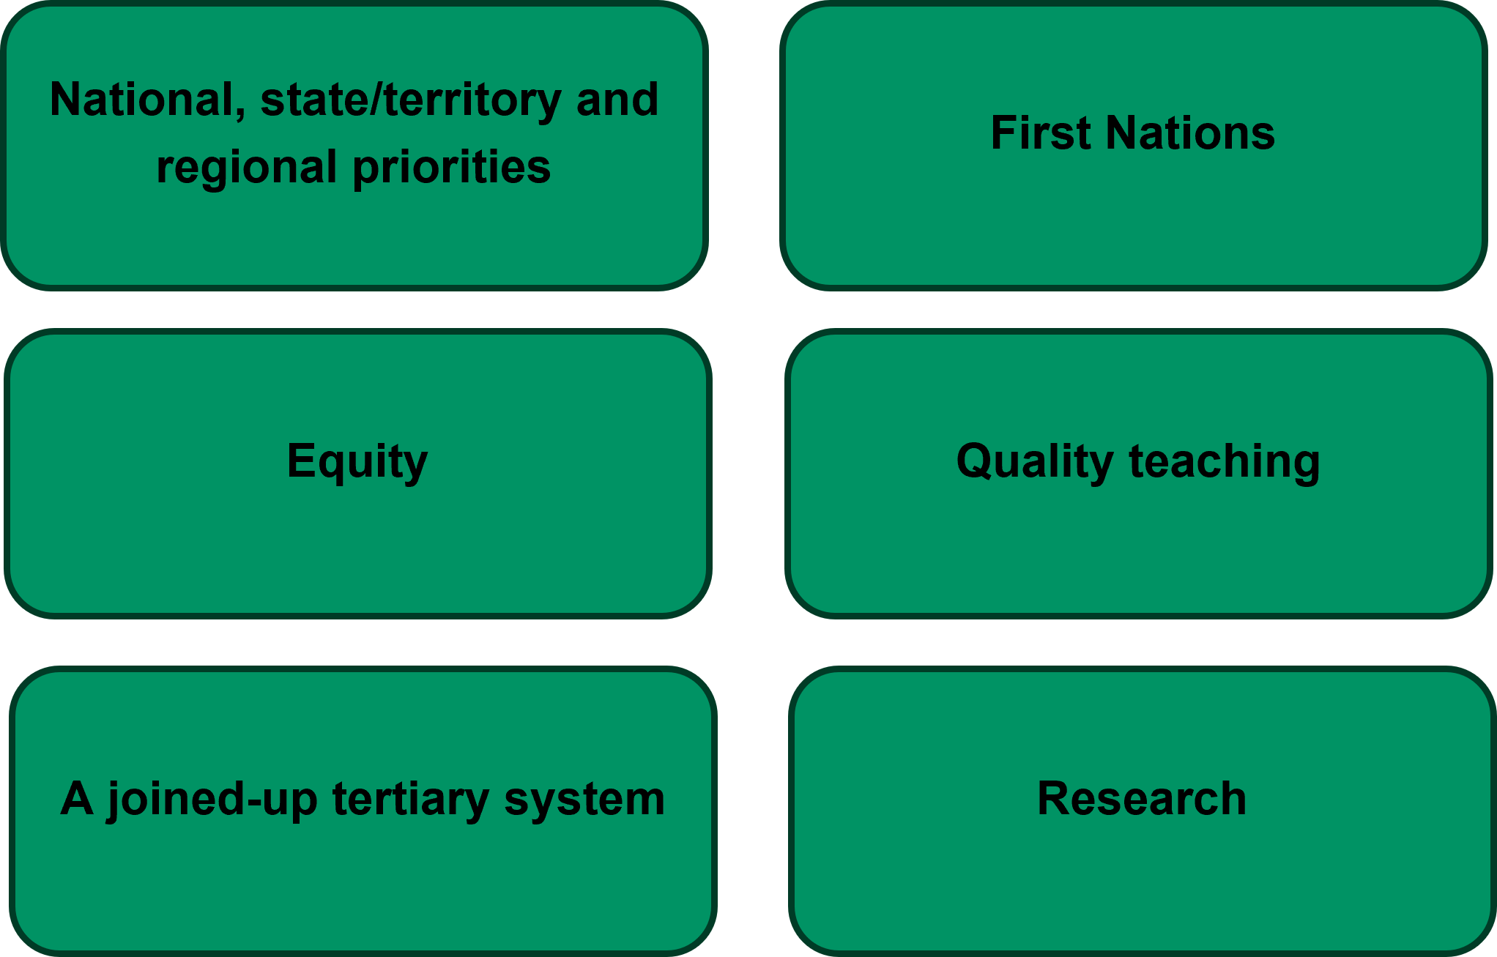
Proposed new priority areas


National, state/territory and regional priorities

Driving increased attainment aligned with critical workforce needs
Building a highly skilled workforce is essential to Australia’s future economic prosperity, productivity, resilience and competitiveness. As industries evolve and new opportunities emerge, the tertiary education system, through teaching and learning and research excellence, plays a critical role in developing the knowledge and skills workers need to meet current and future workforce demands. This is particularly important in areas of national significance, including care services, education, digital technologies, sovereign capability and food security, housing and construction, and the transition to a net zero economy. Increasing attainment in these fields helps ensure Australia has the talent and expertise required to support economic growth, deliver essential services and respond to emerging challenges.
Tertiary education also develops the civic, professional and leadership capabilities needed for Australians to participate fully in society, contribute to their communities and respond to complex national challenges. Workforce needs, economic priorities and community aspirations vary across jurisdictions and regions, requiring place-based approaches that reflect local circumstances. Recognising these diverse priorities within tertiary education planning can support a more responsive, coordinated and future-focused system, helping learners gain the knowledge and skills they need while ensuring communities, industries and governments have access to the workforce capabilities required to thrive.

First Nations

Empowering First Nations leadership and enabling self-determination
First Nations self-determination is fundamental to achieving equitable, culturally responsive and sustainable outcomes across Australia’s education system. First Nations peoples must be supported to exercise authority over the governance, policies, programs, funding and institutions that affect their education, communities and futures. Embedding First Nations priorities and knowledges within decision-making helps ensure that education systems reflect the aspirations of Aboriginal peoples and Torres Strait Islander peoples while creating the conditions for lasting change. This includes creating opportunities for First Nations peoples to shape and lead reform.
Enabling self-determination is critical to achieving sustained improvements in participation, success and educational outcomes. Strengthening First Nations authority, custodianship and leadership in governance, design, delivery and evaluation of tertiary education policy and programs supports more effective and sustainable outcomes for First Nations students and communities.

Equity

Enabling increased access, participation and success of cohorts facing barriers to higher education
Students from underrepresented groups, students from low socioeconomic backgrounds, those living in regional and remote areas, and people with disability, often face systemic barriers that limit both entry to and success within higher education. Addressing these barriers helps ensure educational opportunity by capability and aspiration rather than circumstance, supporting social mobility and strengthening confidence in the fairness of the tertiary education system.
Improving participation, progression, retention, completion and attainment for these cohorts is also essential to meeting Australia's future workforce, economic and productivity needs. As demand grows for highly skilled workers across key sectors, increasing participation and completion rates among underrepresented groups expands the nation's talent pool and helps address skills shortages. Enabling student success through targeted policies, support services, reformed curriculum and flexible pathways and lifelong learning opportunities improves individual outcomes while contributing to a more diverse, skilled and resilient Australia.

Quality teaching

Improving learning and teaching quality in higher education
The Accord highlighted the importance of growing Australia’s higher education system while maintaining and enhancing quality across the student experience. A high-performing and sustainable tertiary education system must meet the educational needs of all students, ensuring that learners have access to engaging, inclusive and supportive learning environments. This includes harnessing the benefits and managing the risks of artificial intelligence (AI) to drive improved learning outcomes for students and deliver teaching more efficiently.
High-quality teaching is central to student success, graduate capability and long-term national benefit. Excellence in teaching helps students develop the knowledge, skills and capabilities needed to thrive in further study, employment, civic life and community leadership. Supporting continuous improvement in teaching practice, promoting innovation and evidence-based approaches to learning, and ensuring all academic staff are well prepared to facilitate good teaching will enhance educational quality and improve student engagement, achievement and success throughout their studies and beyond.

A joined-up tertiary system

Improving the connection between vocational education and training and higher education
Australia’s tertiary education system comprises two distinct but interconnected sectors: vocational education and training (VET) and higher education. While each sector serves a different purpose, learners increasingly move between them throughout their lives as they pursue further study, gain new qualifications, upskill, reskill and transition between careers. A more joined-up tertiary system enables learners to move more easily between sectors by reducing unnecessary barriers and creating clearer, more accessible pathways. This will make it quicker and cheaper for learners to gain the skills they need and for those skills to be deployed in the labour market.
Improving connections between VET and higher education includes strengthening credit recognition, reducing unnecessary duplication of learning and supporting lifelong learning opportunities. Greater integration across the tertiary system can improve learner experiences and outcomes, enhance mobility and progression, increase participation and attainment, and help Australia respond more effectively to future workforce and economic needs.

Research

Strengthening Australia’s research and research training system
Research and research training are fundamental to Australia’s long-term economic prosperity, social wellbeing, sovereign capability and national resilience. Universities play a critical role in generating new knowledge, driving innovation, informing evidence-based policy and developing the advanced capabilities needed to address emerging national challenges. Research training builds the next generation of researchers, academics and highly skilled professionals, strengthening Australia’s sovereign capability, productivity and international competitiveness. AI will be an important tool in building and maintaining Australia’s strong reputation for research with work ongoing to ensure that it is leveraged in the national interest.
The Accord reaffirmed the importance of a strong university research and research training system in sustaining national capability and supporting innovation. Maintaining a healthy research ecosystem and a strong pipeline of postgraduate researchers is essential to ensuring Australia continues to develop the expertise, knowledge and workforce capabilities needed to meet future societal, industry and national priorities.

Global engagement

Supporting global engagement and international standing
International education and research, including transnational education, is a national asset that strengthens Australia’s economic prosperity, global engagement, workforce capability and international reputation. Consistent with the Accord’s vision for a more planned, transparent and nationally aligned tertiary education system, a strong, secure and sustainable international education sector supports research, innovation and cultural exchange, while enriching learning environments and building enduring connections between Australia and the world.
The Accord emphasised the importance of balancing the significant economic, educational and cultural benefits of international education with sustainable growth, high-quality student experiences and strong sector integrity. Maintaining this balance is essential to preserving Australia’s international standing as a world-class tertiary education and research system and ensuring international education and research continue to support national priorities, including research, skills development, workforce needs and long-term prosperity.

Collaboration

Higher education, industry and community partnerships
A connected, coherent and responsive higher education system depends on strong partnerships across higher education providers, industry and communities. As Australia seeks to achieve the National Tertiary Education Objective, collaboration within and beyond the higher education system can strengthen participation, attainment, learning quality, research impact and community outcomes.
Collaboration within the higher education sector can help meet learners’ needs and workforce requirements more efficiently and effectively, particularly in niche subject areas or thin markets. Partnerships across higher education, industry and communities help ensure tertiary education remains relevant, accessible and aligned with future economic and social needs. Strong partnerships with employers support work-integrated learning, curriculum relevance, workforce development and research translation. Community partnerships help ensure the higher education system remains responsive to local priorities and contributes to broader social, cultural and economic development.

Student experience and safety

Improving the student experience and ensuring the safety of all students
A high-quality student experience and student safety is fundamental to achieving equitable access, participation and success across the tertiary education system. A positive student experience supports academic achievement, wellbeing, belonging and engagement, enabling all learners to realise the full benefits of tertiary education. As participation expands, particularly among underrepresented and disadvantaged groups, providers must ensure that learning environments are inclusive, accessible and responsive to the diverse needs of students.
Student safety is equally critical to maintaining trust in the tertiary education system and ensuring that all students can study in environments that are psychosocially supportive and free from harm, discrimination and harassment. Safe and supportive campuses, workplaces and online learning environments are essential for student wellbeing, educational success and positive long-term outcomes.

Consultation Questions
- Do the draft outcomes meaningfully reflect progress towards the National Tertiary Education Objective and ATEC’s legislated goals? Would achieving these outcomes demonstrate a high quality and sustainable tertiary education system?

- Do the draft priorities appropriately reflect the key areas that ATEC should focus on throughout 2027 and 2028? Are there any key focus areas within ATEC’s remit that should be added, consolidated, refined or removed, and why?

- Reflecting on the interim SSP and foundation mission based compact process, are the proposed priorities practical and useful in enabling providers to reflect their unique missions and operating contexts?

