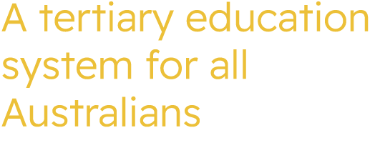

ATEC Meeting
Tuesday 20 October 2026

Meeting Communique
The Commissioners met in person on Tuesday 20 October 2026 and commenced with an Acknowledgement of Country.
The Commissioners:
- discussed Regional University Study Hubs (RUSH) and Commonwealth Supported Places (CSP) including the interdependencies between CSP allocations and RUSH program funding arrangements.
- Approved, in principle, an internal ATEC Committees Policy to set out the requirements, considerations and best practice for establishing committees under section 25 of the Universities Accord (Australian Tertiary Education Commission) Act 2026.
- discussed progress in relation to the development of the Higher Education Threshold Standards in relation to research security.
- noted a verbal update on development of the Statement of Strategic Priorities, including progress on ongoing consultation activities.
- received a presentation from and discussed the role, and key focus of, the National Student Ombudsman (NSO) with an invited speaker from the NSO, including future collaboration and knowledge-sharing opportunities and a regular mechanism for ATEC and NSO engagement.
- agreed a process for noting course closures and approving campus changes relating to the delivery of Commonwealth Supported Places.

ATEC Commissioners
Professor Barney Glover AO, Chief Commissioner (Chair)
The Hon Fiona Nash, Commissioner
Professor Stephen Duckett AM, Commissioner
Professor Mark Rose AM, First Nations Commissioner
Mr David Coltman, Commissioner

Apologies

