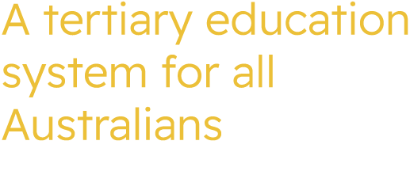

ATEC Commissioner Meeting
Tuesday 14 July 2026

Meeting Communique
The Commissioners met online on Tuesday 14 July 2026.
The Commissioners:
- Agreed to publish the Working Group on Higher Education Costing and Pricing – Summary of Progress to Date report on ATEC’s website.
- Discussed the approach to developing the Statement of Strategic Priorities for 2027 and 2028 calendar years, including consultation plans for the second half of 2026.
- Agreed to progress advice on the distribution of the $50 million Structural Adjustment Fund to the Minister for Education for consideration.
- Noted the Minister for Education’s recent amendments to the Higher Education Standards Framework (Threshold Standards) 2021.

ATEC Commissioners
Professor Barney Glover AO, Chief Commissioner (Chair)
The Hon Fiona Nash, Commissioner
Professor Stephen Duckett, Commissioner
Professor Tom Calma AO, Interim First Nations Commissioner

Apologies
Mr David Coltman, Commissioner

